Celebrating World Tourism Day with Travind Institute
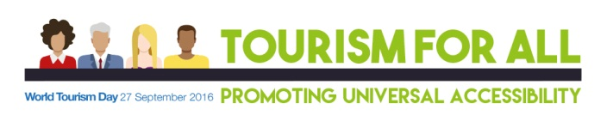
Travind Institute of Travel & Tourism Management India Pvt Ltd. Has played a major role in creating awareness for Travel & Tourism Industry.
We have engaged the Students to train and prepare candidates to be ready to excel in the service industry.
As an educational facilitator Travind will be able to reach out to the grass root level of academic in order to generate skill development and Tourism Professionals/Candidates.

Travind Institute is moving ahead with a motive to reach to the rural and remote areas in and around Pune or Maharashtra, with sole motive of generating awareness amongst the students about -
1. Tourism and Hospitality
2. Travel and Tourism
3. Hotel Administration
4. Over all Service Industry.
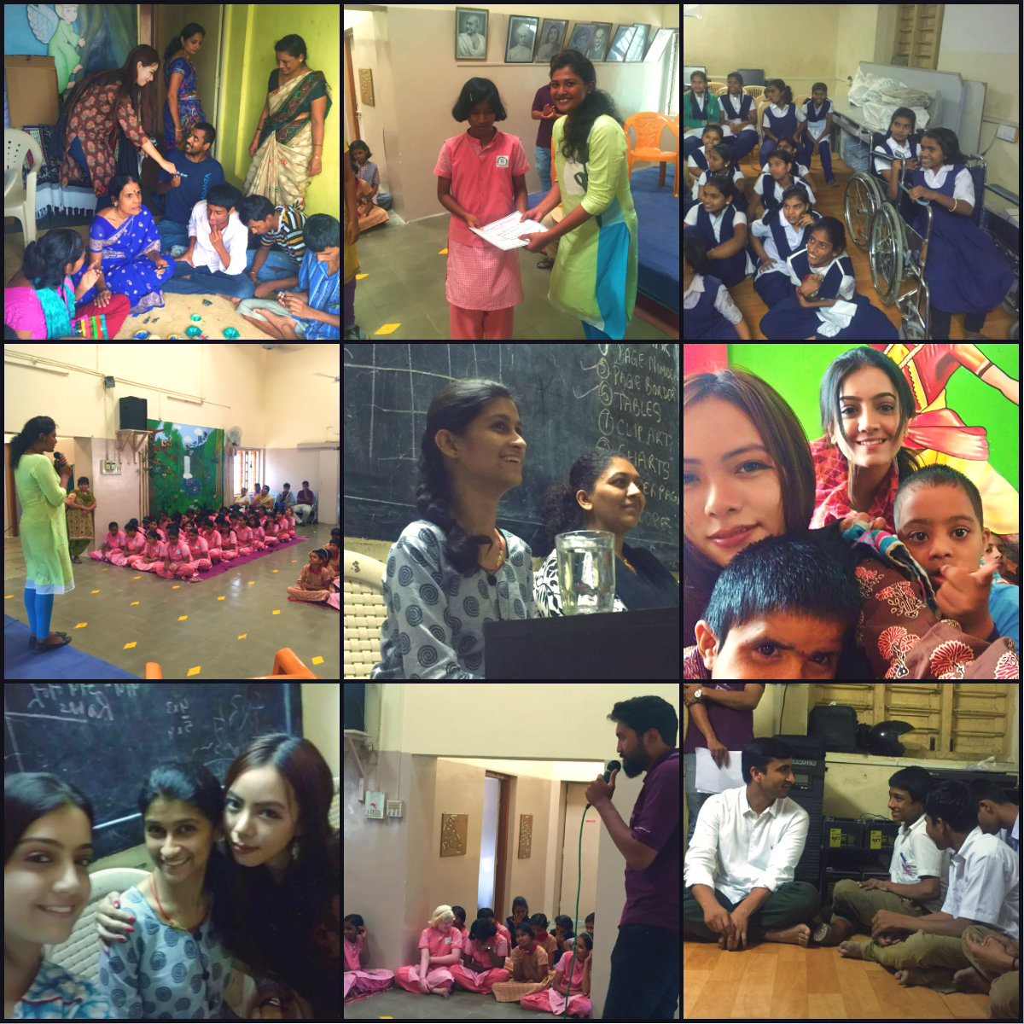

The main motives under the foundation was –
1. To introduce the students, differently able to the Travel & Tourism Industry and service industry as a whole.
2. Guide them with all the opportunities available in the service industry.
3. Counsel them with their academic problems and help them with the solutions.
4. Educate them with free workshops in communication skills, spoken English, etc which will boost the student’s confidence before starting the career and help grab any good opportunity.
5. Guide them use their knowledge in the right field.

Now being a part of this Industry they are been involved in promoting the theme of UNWTO i.e.
“ Tourism for all- promoting Universal Accessibility” by visiting various NGOS and Schools of disable students and having a session with them to make them aware about the Importance of International Tourism and various facilities in this made for them by the Government.
Places Visited by Travind Institute of Travel & Tourism Management:
1.Poona ​ School and Home for Blind,Kothrud,Pune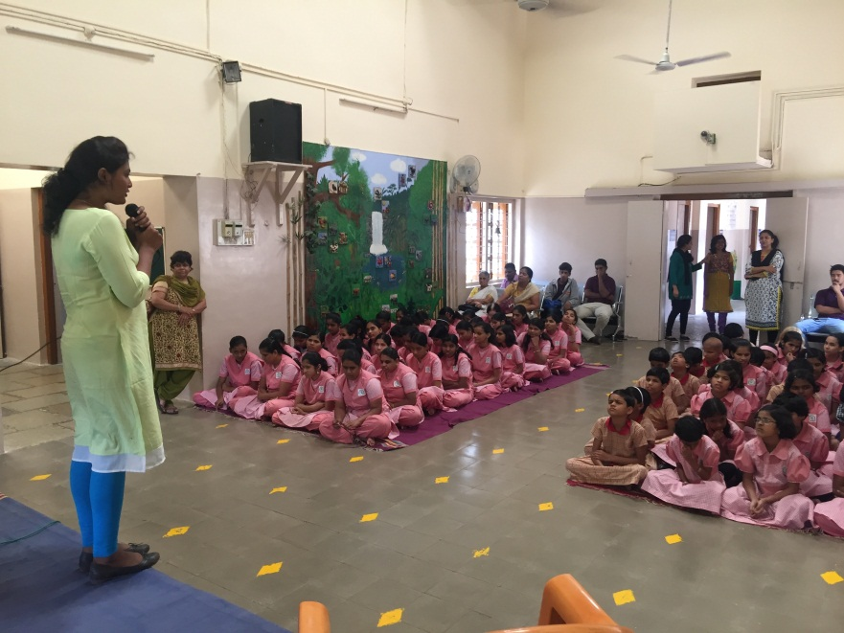
2. Aksharsparsh Matimand Nivasi Vidyalaya,Katraj,Pune
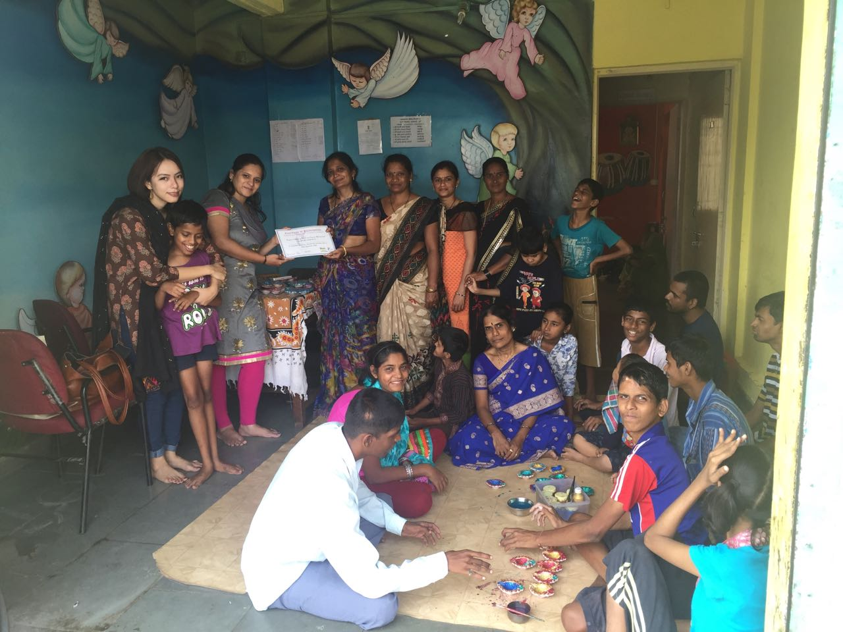
3. Shree Haribhai Balavanthrao Girame Vidyalaya,Wanawadi,Pune
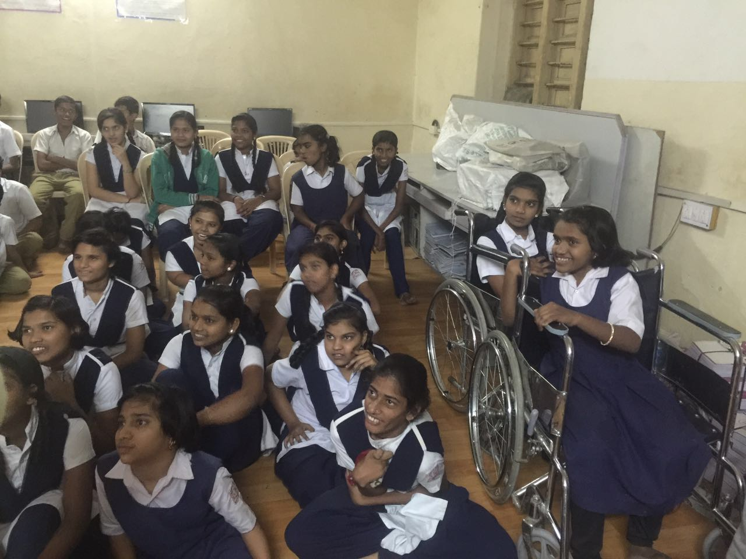

Speaker:-
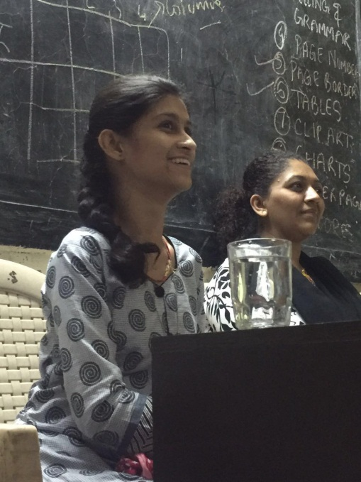
Ms. Diksha Dinde
Global Youth Ambassador of United Nations
A young girl who aspires to use her ideals and education to make lives of larger number of children, young people and women easier, to help them develop to the best of their ability and to ensure that the opportunities they need are provided to them. She has realized none of these goals are easy to achieve, but she is driven with enough grit and reason to continue to give her best to fulfill them.
On 27th September 2016 on the occasion of World Tourism Day , In Shree Haribhai Balavanthrao Girame Vidyalaya ,where many differently able students were present, She shared her views on importance of Tourism for them and the facilities are to be provided for them in while Traveling, she also shared her experiences of her adventures and being differently abled how she overcomed the hurdles.
she shared her two of her incident of the visit to Gadchiroli alone as Ghadchiroli is not a diffent-able friendly place but how she won the battle too.
and when she went once to watch the cricket match and she found that the infrastructure is not well and the facilities were not there for disabled persons. So she filed a PIL against this problem and wanted government to take some action for this. She also mentioned that she has done trekking in Sinhagad.
Her presence was not only an inspiration for the differently abled but also for those who are pretty much normal.

