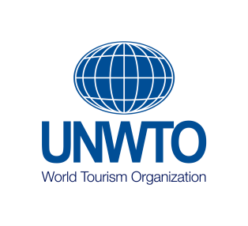

Sample letter of acceptance of the Statutes of UNWTO and commitment to the UNWTO
Global Code of Ethics for Tourism
(This letter must be written on official stationery with the letterhead and seal of the applying entity)

_________________
(Place and date)

Subject: Acceptance of the Statutes of UNWTO and commitment to the UNWTO Global Code of Ethics for Tourism

To: Mr. Ion Vilcu
Director
Affiliate Members Department
World Tourism Organization
Poeta Joan Maragall, 42
28020 Madrid (Spain)

From: (Name and address of the company/entity/organization)

Tel.: (dialling code and number)
Fax: (dialling code and number)
E-mail: ____________________________________

In my capacity as (title) of the above-mentioned entity, I hereby declare that we have taken cognizance of the Statutes of the World Tourism Organization, that we adopt the objectives of the Organization as our own, that we undertake to constantly make an effort to practice and develop the principles of the Global Code of Ethics for Tourism of the UNWTO and accept the obligations inherent to affiliate membership as set forth in the Statutes of the Organization and in Article 2 Section 2 of the Rules of Procedure of the Committee of Affiliate Members.

Signature:
Name:
Title:
(Official Seal)

